


Mill of Mains
Contents
Our Setting………………………………………..page 3
Exploring our wider environment……………….page 7
Documentation…………………………………...page 8
Our Vision and Values…………………………..page 9
Learning Journals………………………………..page 10
Our Nursery Team……………………………….page 11
Settling in………………………………………....page 13
Seesaw……………………………………………..page 13
Medical…………………………………………….page 14
Family Involvement……………………………...page 14
Checklist…………………………………………..page 16
Collection Sheet………………………………….page 17
Permission Slips…………………………………..page 18
Childsmile…………………………………………page 20

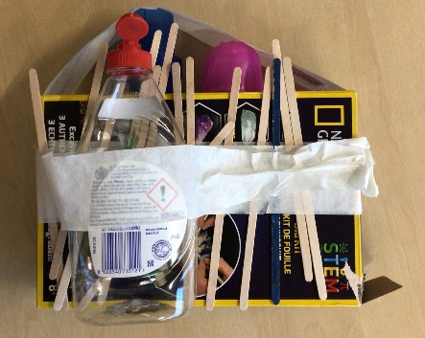
“Our aim is for children to create from their imagination rather than following instructions.”
Our Setting
We would like to welcome your family to Mill of Mains Nursery. This handbook gives you all the information you will need for starting with us.
Our nursery offers free flow play indoors and outdoors, for children aged 2-5 years old. We engage in child-led planning, this means we follow your child’s interest and pace of learning and support this through play activities and experiences. We use planning floorbooks to make children’s learning visible and follow their interests, you are welcome to have a look at these at any time!

Here are some photos of our setting:
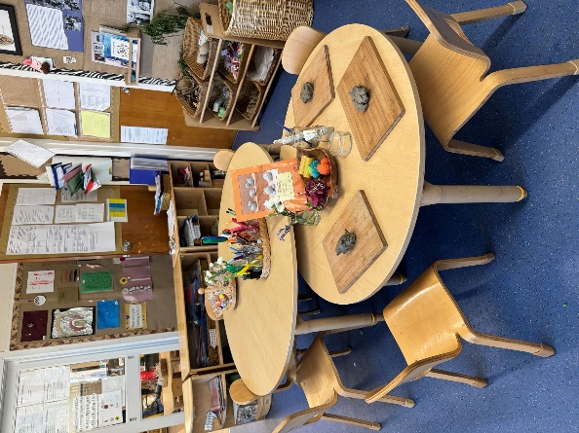 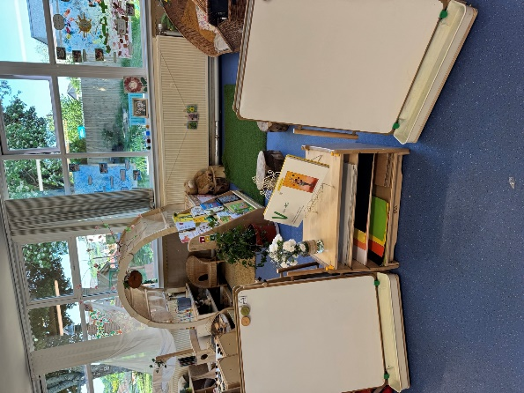 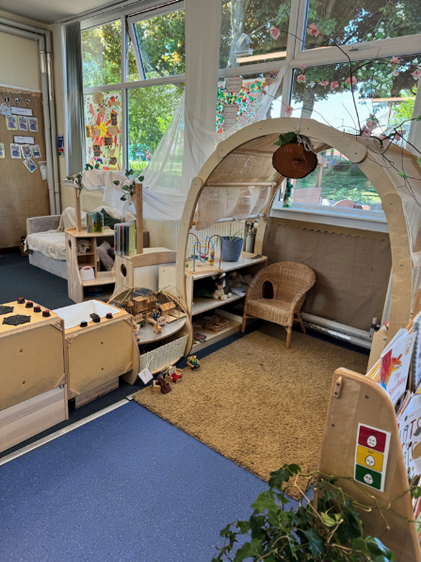
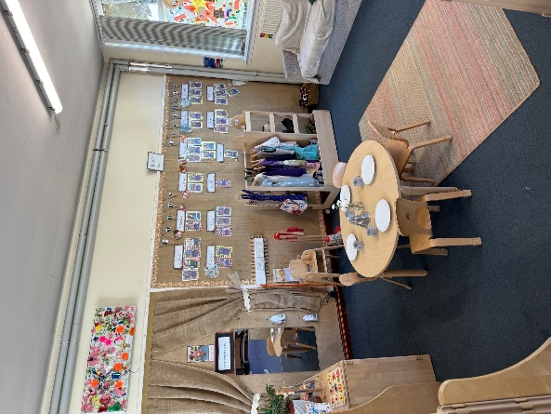 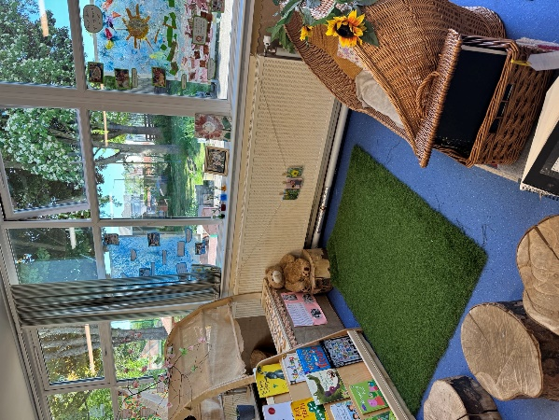
“I been cutting”
“dressing-up”
“playing games at group”
“for calming down”
“my painting my mummy”

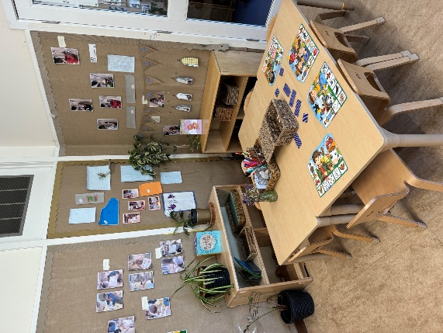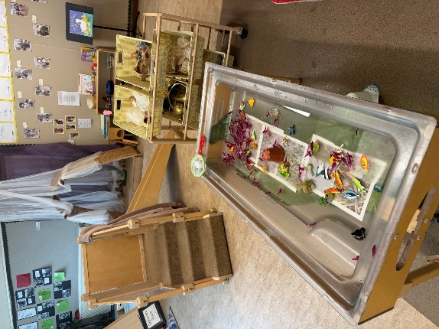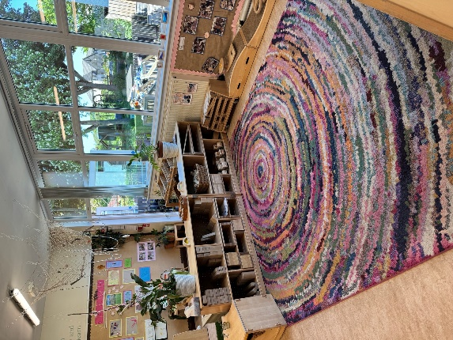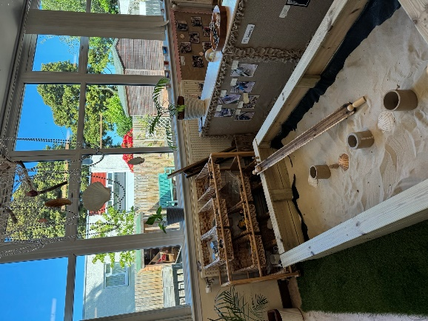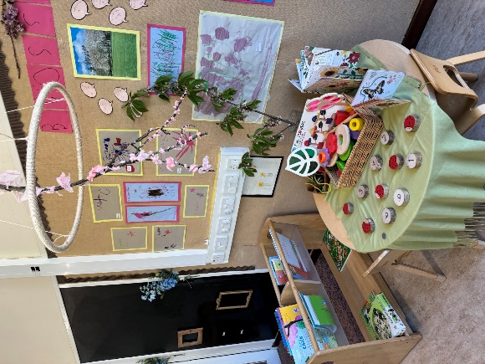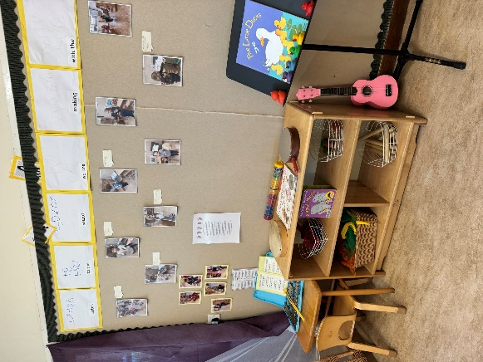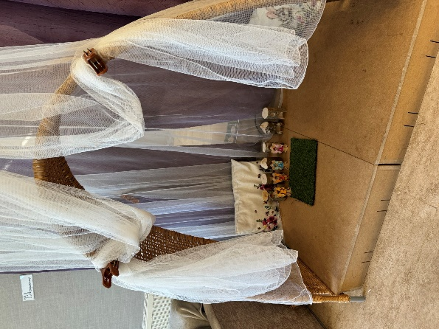
“I splashing”
“building things ‘cause my like to build”
“I builded a castle”

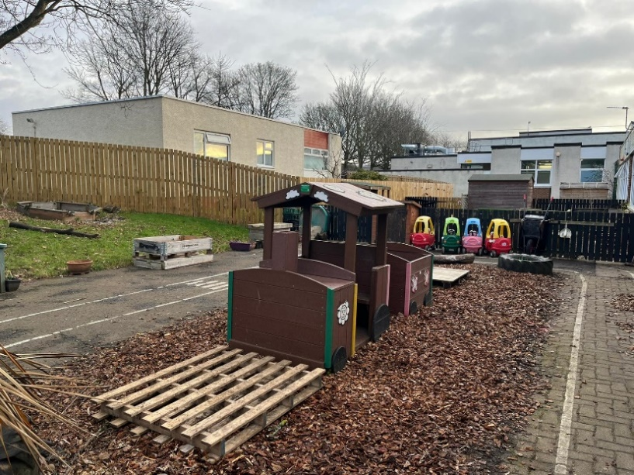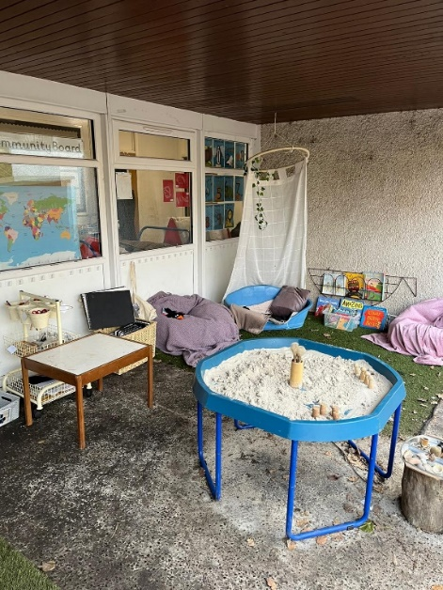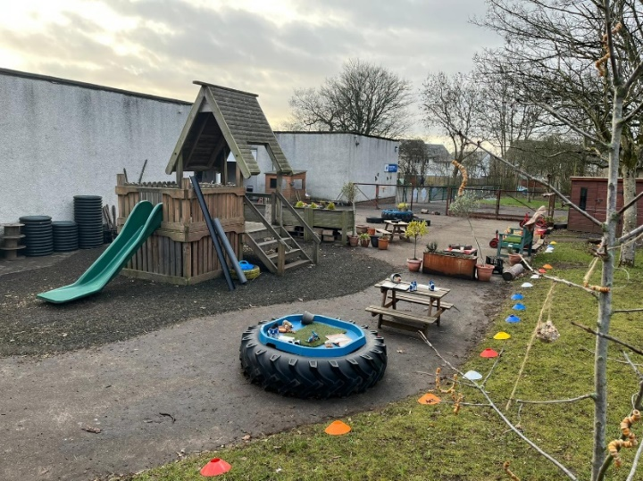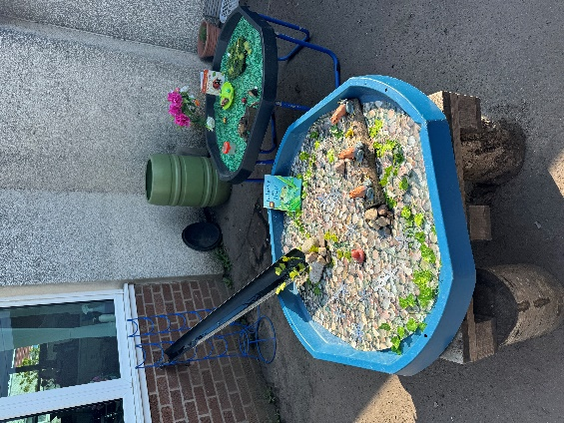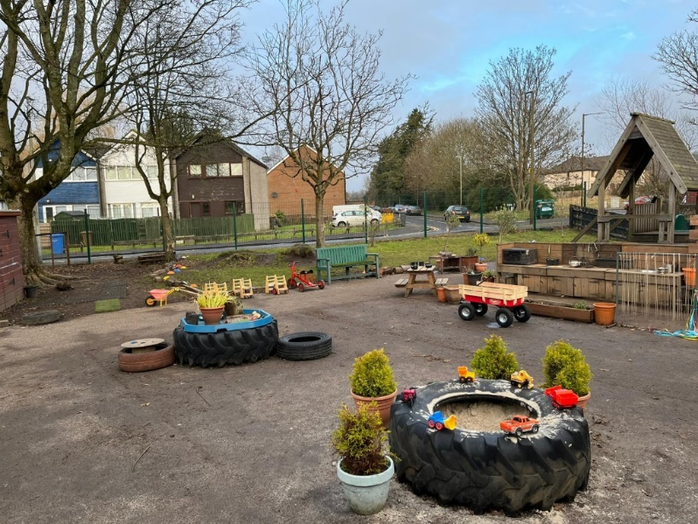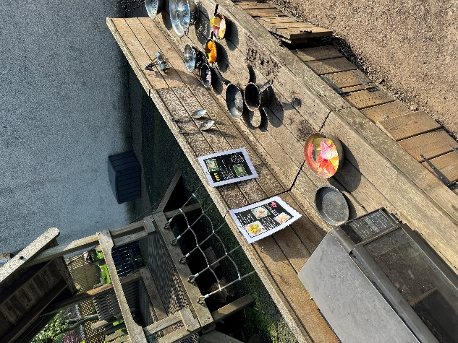
“I like going down the shoot”
“making rockets”
“make a volcano with the mud”
“make cakes”
Our nursery setting is always developing to meet the needs and interests of children, so it might look a little different when you come in to visit!

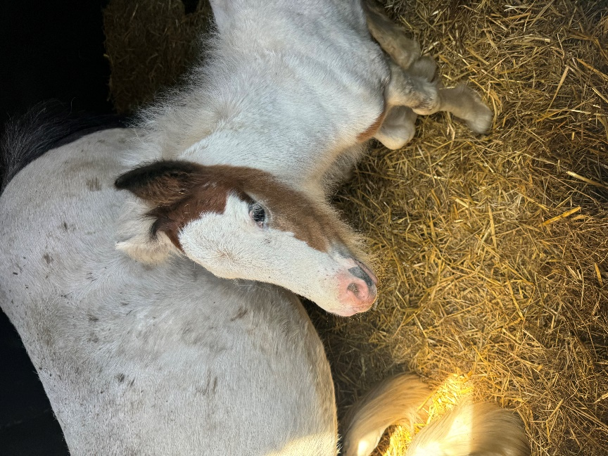
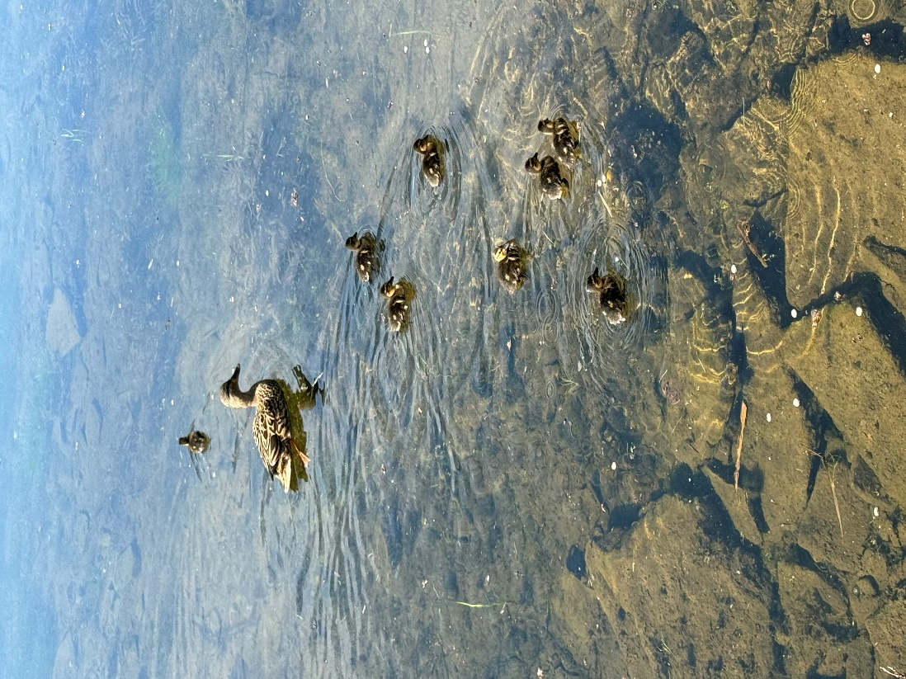
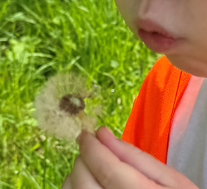
“The mud will wash off, but the memories will last a lifetime.”
Exploring our wider environment
We are very lucky to have such wonderful learning opportunities right on our doorstep, such as Trottick Ponds and the Claverhouse Equestrian Centre. To make the most of this, we make frequent trips to visit and explore our local environment and make links within the community.
We are always more than happy for you to come along on any of our trips, just let a member of staff know if you are interested.

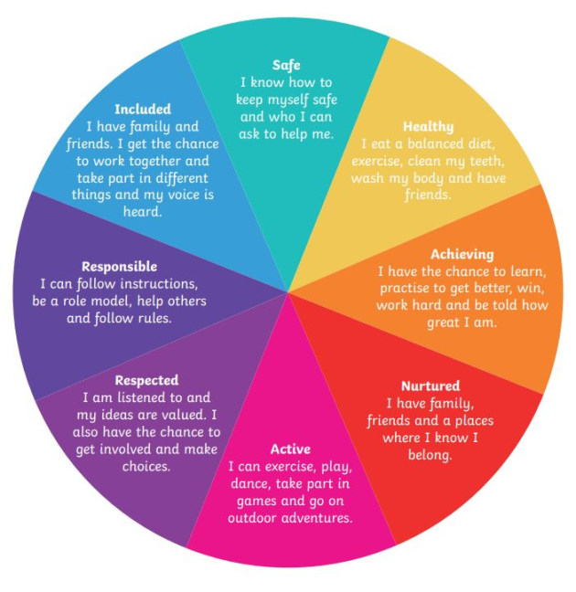
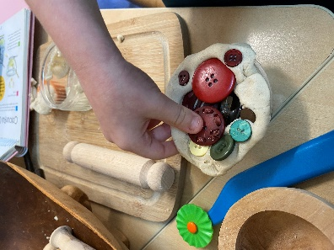
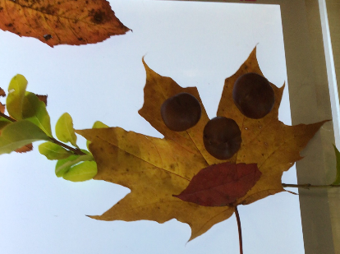
“Children need the freedom to appreciate the infinite resources of their hands, their eyes, and their ears.”
Documentation
The GIRFEC Wheel
“Getting it Right for Every Child” (GIRFEC) is embedded in our practice and enables us to meet the needs of all children. There are 8 wellbeing indicators at the heart of the GIRFEC approach, commonly known as SHANARRI wellbeing indicators. These are: safe, healthy, achieving, nurtured, active, respected, responsible and included. These indicators help make it easier for children and families to achieve their full potential.
Documents we use are Curriculum for Excellence to track children’s learning and plan experiences and opportunities for your child to engage in. We also use Learning Together in Dundee, which supports us in the continuous development of our practice.
“You can’t use up creativity, the more you use, the more you have.”
Our Vision and Values
Our vision and values have been developed in collaboration with the school, these are:
“I love my nursery teachers”
“playing in the mud kitchen”
Our Vision:
Happy Together,
Learning Together,
Succeeding Together.
“reading books”
“I learned about my friends”

“I can jump like this!”
“play nicely”

“when we ask for something”
“using my quiet voice”
“playing with my friends”
“people play with me”

“listen to stay safe with your ears”
“don’t go on wobbly blocks”
Our Values:
Be respectful, be safe, be happy.
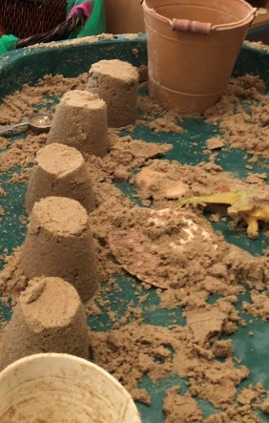
“Children learn as they play. Most importantly, children learn how to learn through play.”

Learning Journal
Your child will be given their own learning journal, which will include photos, mark-making and your child’s voice. This is how we record your child’s learning experiences in nursery, and you are welcome to look at this at any time. You can also take your child’s journal home to add to on a regular basis, we love to see the things you get up to, and it helps us get to know you and your child a bit better.
Here are some examples of the things you might like to add..
If you need any resources (glue, pens) we have packs available, just ask a member of staff. We can also print your photos off too, you are always more than welcome to send us them on SeeSaw!
Our Nursery Team


Upon starting nursery, your child will be given a highly qualified Early Years Educator (EYE) as a keyworker. This is the person responsible for recording and tracking your child’s learning and will work alongside your family to support your child at nursery and at home. We have 5 key groups within the room, these are the Sunflowers, Sweetpeas, Bluebells, Poppies and Daisies. Our Senior Early Years Practitioner (SEYP) is Karen Deuchars, who is available to answer any queries and support your family where possible. Our Nursery Teacher is Emma Milne, who is responsible for leading the learning, planning and assessment and supporting your child to become a successful learner. We also have two Early Years Support Assistants (EYSA), Stacey Ness and Jayne Duncan, who are there to support children and staff. Our head teacher is Ashley Matheson, and our nursery manager and deputy head is Aine Wise.
Here are some photos of our team, we have added in their favourite story too!

Karen Deuchars
SEYP

Emma Milne
Nursery Teacher

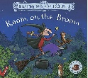






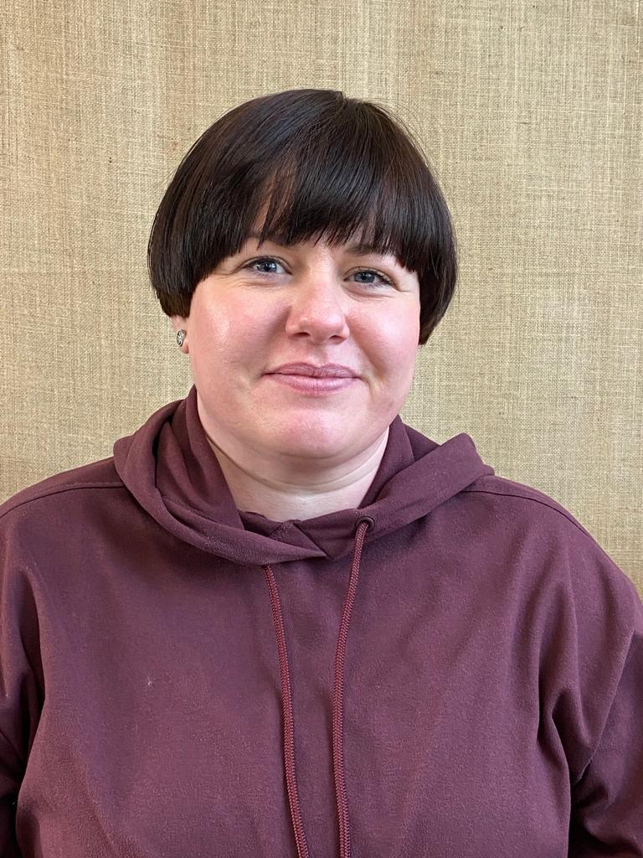
Jayne Duncan
EYSA

Stacey Ness
EYSA
Kim Reid
EYE
Keyworker of the Bluebells

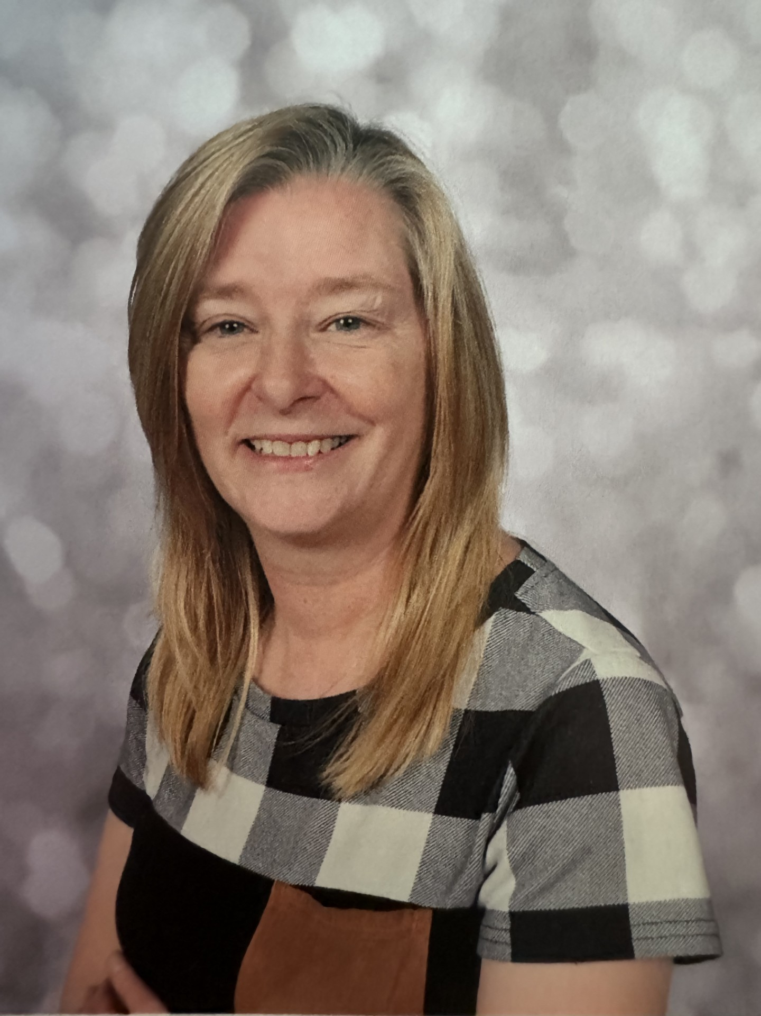
Kim Scott
EYE
Keyworker of the Poppies


Nicole Duncan
EYE
Keyworker of the Sunflowers


Adele Turfus
EYE
Keyworker of the Sweetpeas
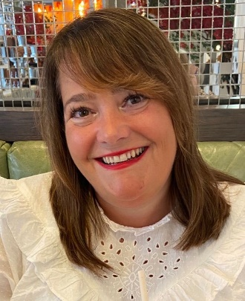
Pauline Fleming
EYE
Keyworker of the Sweetpeas

Natalie Sturrock
EYE
Keyworker of the Daisies


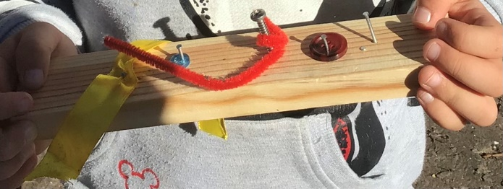
“Our task regarding creativity, is to help children climb their own mountains, as high as possible.”

Settling Into our Nursery Routine
On your first visit, you will be given an “All About Me” form to fill out with a member of staff and your child, this gives us all the information we need to ensure a smooth transition for you and your child. The settling-in process will be unique to each child, and we will work with you to plan how best we can support your child’s transition to the setting. There are two options of core hours that you may choose for your child, these are 8:30am – 2:30pm or 9:00am-3:00pm.
Once your child has settled in, we ask that they are dropped off and collected on time to ensure maintenance of child to staff ratios. We understand that there are times you may be running late, we just ask that you give us a call to let us know. Can you please contact us before 9.30am otherwise a lunch cannot be ordered for your child. You will have to provide a packed lunch for them. Our nursery number is 01382 438571. To help give you and your child an idea of what to expect, here is our nursery routine:
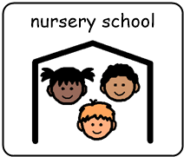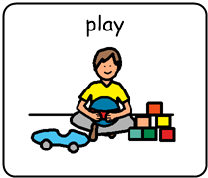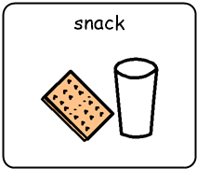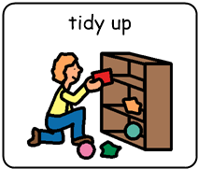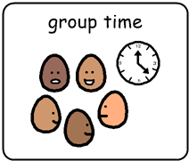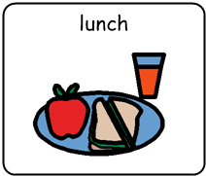
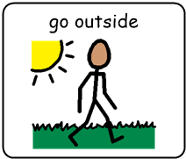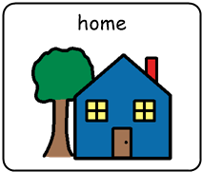
Our nursery routine is flexible and can be adapted to suit the needs of individual children.
At nursery, your child will be given a choice of two options for their lunch that day provided by Tayside Contracts. The lunch menus are on a four week rotation, these are included in your starter pack. If your child has any allergies, dietary or cultural requirement, we ask that you inform us of this on your first visit to the setting to ensure we can make arrangements.
The children are offered a morning snack which we plan and prepare together, and there is always milk and water available for them to drink. These snacks always include fresh fruit, and things like toast, cereal, and yoghurts. Our children work with the staff to plan their snack menus for the following weeks.
As part of the Childsmile programme, the children are given the opportunity to brush their teeth in nursery once a day. You will be given a permission slip for this.

Seesaw
We use Seesaw to give your family access to photos of your child’s learning and experiences, this is an App that can be downloaded to your phone or other device. This allows you to see updates of what your child is doing at nursery, and can be used as a means of communication between families and staff. Our nursery teacher Emma will provide you with a special code which will connect you to your child’s Seesaw journal.

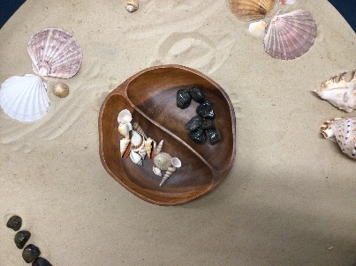
“Play is our brain’s favourite way of learning.”

Medical
If your child has any medical needs, we ask that you ensure our Senior Karen is aware of this on your first visit to the setting. This allows us to ensure we have planned for your child’s needs.
If your child has had vomiting or an upset stomach, we ask that you keep them off for 48 hours from the last time this occurred. If this occurs when they are at nursery, we will phone the emergency contacts you have left with us so your child can be picked up. This also applies if your child is unwell or unsettled- if we feel they are not coping with their nursery day we will ask for them to be collected. If you are keeping your child off, we ask that you give the nursery a phone to let us know.
Family involvement
At nursery, we offer lots of opportunities for our families to engage in their child’s learning and development. We do this by offering regular Stay & Play sessions, and a variety of groups that you will have the opportunity to attend. More information about these groups and sessions will be given when these are available. We ask that you use the nursery checklist provided to ensure you and your child have everything you need for starting with us at Mill of Mains Nursery. We are looking forward to meeting you!

Checklist for starting nursery
Please ensure that children are sent to nursery in shoes that they can attempt to put on independently. Laced shoes should only be provided if your child can tie them otherwise slip on or velcro are recommended.

Please ensure that all articles have your child's name on them.
Checklist | Returned
Take a note of the nursery contact number – 438571  (Use this number to call if your child is absent). | Y/N
Complete Permissions Form | Y/N
Complete Collection Form. | Y/N
Complete All About Me. | Y/N
Factor 50+ sun cream | Y/N
Welly boots – hand to key worker | Y/N
Waterproof trousers and raincoat/ Rain or Snow suit  We go outside in all weather and these let us play freely. | Y/N
Gym shoes (not trainers)  These are worn indoors to keep our floor clean for playing on. | Y/N
At least 1 set of spare clothes – play can sometimes be messy/ wet – remember spare socks and pants too! | Y/N
If your child requires pull-ups/nappies and wipes, please ensure you provide plenty of these.
Lunches are free of charge for all children. Please let us know if your child has any existing or new dietary requirements.

Parent Pay – all payments should be made using Parent Pay where possible. If you do not have a code for ParentPay please contact the school office on 01382 438568.
https://app.parentpay.com/public/client/security/#/login
Name | Relationship to Child | Contact number
Mill of Mains Nursery School Collection Sheet
Please record the names and details of the persons who have permission to collect your child from nursery. Please note that only persons over the age of 16 are permitted to collect your child. We will only allow people noted below to collect your child. In the event that someone comes to collect your child who is not on the list, you will be notified and your child will remain in nursery until permission is granted. Remember to add your name/ number.
To be reviewed every 3 months.
Name: _______________ Date:________________
Name: _______________ Date:________________
Name: _______________ Date:________________
Name: _______________ Date:________________
Permission Slips
Internet Safety, Media Permission & Acceptable Use of ICT in Dundee Schools
You can find out more about Dundee’s guidelines on internet safety at http://dc2.ea.dundeecity.sch.uk/,
I have read the rules for Acceptable Computer and Internet Use and understand that these rules apply when my child is using ICT (including both school and personal computers and devices) and the internet.
I have gone through the rules with my child and explained their importance and the consequences of breaking the rules, and ensured that they understand.
I understand that the school will make every reasonable effort to restrict access to all controversial material on the Internet, but I will not hold them responsible for materials my son or daughter acquires or sees as a result of the use of ICT at school.
I also accept that the school cannot be responsible for any loss, theft or damage to personal equipment my child may bring to school e.g. smartphone, iPod, netbook etc.
I give my permission to allow the child/young person named above to use ICT and the internet in school.
Cycling/ Scootering Code of Conduct
Children can cycle/ scoot to nursery and must wear a helmet. All bicycles and scooters should be clearly named and a suitable lock used to secure them.

Sun cream Application
A parent / carer should apply Sun cream before arriving at nursery during warmer weather. Staff will apply it around mid-day at appropriate times of year.
Nursery will supply factor 50+ sun cream for all children, however parents can supply their own if preferred.
Photograph permission
Nursery staff often take photographs to record individual’s learning. These are printed and added to your child’s journal and Nursery floor books.
In addition to this, at various times and events during the nursery year, press photographers and nursery staff may use photographs to promote positive learning experiences across the city. Pupils will not be identified in this type of photograph, comments will only mention the class or activity involved.
Walks around the local area and trips on public buses
From time to time, we may go out on walks around the local community and on public buses.
Seesaw
Messages and photos of your child will be available to view at your leisure. Only parents from the Nursery class can view these as it is a secure site.
Please keep this copy for your records.

Permission Slips
Privacy Statement
In order for us to provide services to you as a Local Authority, we need you to give us your personal information. To deliver our services, to meet our legal obligations and protect public funds we need to collect, store, use, share and dispose of personal information. This is known as data processing. We also use your information to verify your identity where required, contact you by post, email or telephone and to maintain our records.
We collect and use different categories of personal information, depending on the service we provide to you. Further details on how we use your data with this form can be found on our website www.dundeecity.gov.uk/privacy Alternatively, ask the school for a copy of the full Privacy Statement.
When completing this form, by ticking yes, you are consenting to each of the statements below.

Child’s name _________________________________________

Seesaw  I give consent for my child’s photo to be added to Seesaw. | Yes/ No
Local walks and public buses  I give consent for my child to go out for a local walk and travel on public buses. | Yes/ No
Photograph permission  I give consent for my child’s photograph to be taken for nursery activities. | Yes/ No
Sun cream Application  I give consent for sun cream to be applied to my child. | Yes/ No
Cycling/ Scootering Code of Conduct  I give consent for my child to cycle/ scoot to school. | Yes/ No
Internet safety  I give consent for my child to use ICT and the internet in school. | Yes/ No
I confirm the consents above.

Signature: _____________________________________ Date: ________________

Please return to your child’s key worker at nursery.

Oral Health Improvement Team
NHS Tayside,The Crescent
71 Lothian Crescent
Dundee, DD4 0HU
01382 432060
Tay.oralhealth@nhs.scot
Dear Parent or Guardian,
Childsmile Toothbrushing Programme
Childsmile is a national programme designed to improve the oral health of children in Scotland. Research tells us that brushing at least twice a day with fluoride toothpaste can help prevent tooth decay. To support this, Childsmile has developed a national daily supervised toothbrushing programme to take place in the nursery or school setting, in addition to brushing at home.
The Toothbrushing Standards have been reviewed by Public Health Scotland, the Care Inspectorate and the Chief Dental Officer.
What does the toothbrushing programme involve?
- Children are given their own toothbrush showing a symbol which matches a corresponding symbol on a storage system and wall chart.
- Every day they will be supervised brushing their teeth with their own toothbrush and fluoride toothpaste supplied by the programme.
- All nurseries and schools participating in the toothbrushing programme will follow the National Standards for Toothbrushing.
- We monitor the toothbrushing programme to ensure we provide a good level of service.
Supervised toothbrushing
Children are supervised in the programme because young children need help with toothbrushing on a daily basis. At home, children should be encouraged to toothbrush themselves, but they will still need help and should be supervised with daily toothbrushing. This will help to ensure that they brush well and do not swallow toothpaste. Children who swallow too much toothpaste over a long period of time can develop white spots on their teeth. This is not tooth decay. The risk of developing white spots as a result of the toothbrushing programme is very small.
What do I need to do next?
Your child will be enrolled in the toothbrushing programme automatically at their nursery or school. You do not need to do anything. However, if you do not want your child to take part in the Childsmile toothbrushing programme please write to your child’s nursery or school within two weeks of receiving this letter. You can of course change your mind at any time. Should you have any questions please contact me.
Yours sincerely
Childsmile Team

